Set 2 Question 3
Scenario / Case Study
Razorpay backend monorepo — CI build-graph cycle suspected. The Razorpay engineering monorepo has 9 build targets {auth, payments, kyc, ledger, fraud, notify, admin-ui, customer-ui, gateway}. Yesterday's CI run hung; the build coordinator (which performs a topological sort of the dependency DAG before scheduling parallel build jobs) failed with a generic 'cycle suspected' message. The build engineer captured the dependency edges from the build manifest (edge A → B means "A depends on B; build B before A"): auth→ledger, payments→auth, payments→fraud, kyc→auth, ledger→fraud, fraud→notify, fraud→ledger, admin-ui→payments, admin-ui→kyc, customer-ui→payments, gateway→admin-ui, gateway→customer-ui, notify→gateway. Twelve hours of debugging would have been saved by a clear cycle report.
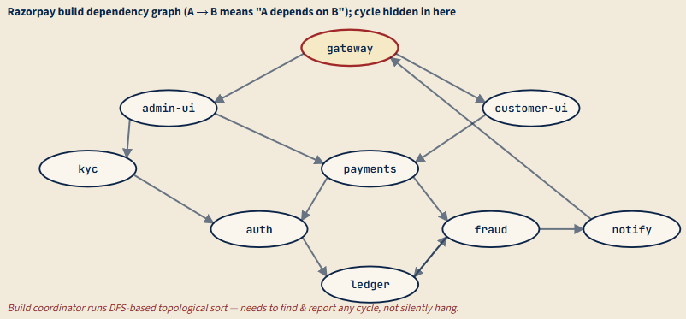

a) Run a DFS-based topological sort with cycle detection on the dependency graph shown. Use the colour-marking scheme (WHITE = unvisited, GREY = on current DFS stack, BLACK = finished). Process vertices in alphabetical order on the outer loop. Show the visit-time/finish-time table or a clear DFS trace, and identify the back-edge(s) that prove a cycle exists. List the vertices on the cycle in order.

Answer:-

1. Colour Marking Scheme
WHITE = Vertex not visited
GREY = Vertex currently in DFS recursion stack
BLACK = Vertex completely processed

2. Outer Loop Vertex Order (Alphabetical)
admin-ui
auth
customer-ui
fraud
gateway
kyc
ledger
notify
payments

3. Start DFS from admin-ui
Initially all vertices are WHITE.
Visit admin-ui.
admin-ui changes from WHITE → GREY.
DFS Stack: [admin-ui]
Visit next adjacent vertex of admin-ui change it color to GREY. It visit vertices one by one and changes its color to GREY.
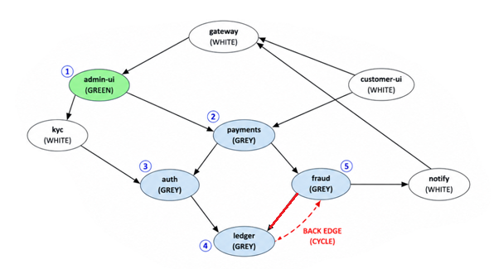
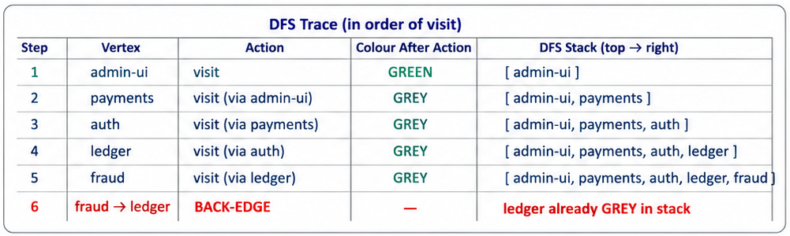
Final Conclusion
- In DFS, a GREY node means the vertex is already in the current recursion stack.
- While exploring fraud, DFS reaches ledger again.
- ledger is already marked GREY.
- So, edge fraud → ledger becomes a back edge.
- Back edge detected:
fraud → ledger
- Cycle detected:
ledger → fraud → ledger
- The graph is not a DAG.
- Topological sorting is not possible.
- The build coordinator fails because circular dependency exists.

(a) DFS-Based Topological Sort with Cycle Detection
The dependency edges are:
auth → ledger
payments → auth
payments → fraud
kyc → auth
ledger → fraud
fraud → notify
fraud → ledger
admin-ui → payments
admin-ui → kyc
customer-ui → payments
gateway → admin-ui
gateway → customer-ui
notify → gateway
DFS uses the colour-marking scheme:
- WHITE = unvisited
- GREY = currently in recursion stack
- BLACK = fully processed
The DFS traversal is performed alphabetically.

DFS Trace
Start DFS at admin-ui.
admin-ui (discover = 1)
→ kyc (discover = 2)
→ auth (discover = 3)
→ ledger (discover = 4)
→ fraud (discover = 5)
From fraud, visit neighbors alphabetically:
fraud → ledger
At this moment, ledger is already GREY (still in recursion stack).
Therefore:
fraud → ledger
is a back edge, proving a cycle exists.
The cycle is:
ledger → fraud → ledger
Continue DFS:
fraud → notify (discover = 6)
→ gateway (discover = 7)
→ customer-ui (discover = 8)
→ payments (discover = 9)
Now recursion finishes in reverse order.

Discovery / Finish Time Table
Vertex | Discovery Time | Finish Time
admin-ui | 1 | 18
kyc | 2 | 17
auth | 3 | 16
ledger | 4 | 15
fraud | 5 | 14
notify | 6 | 13
gateway | 7 | 12
customer-ui | 8 | 11
payments | 9 | 10

Back Edge
The back edge detected during DFS is:
fraud → ledger
because ledger was GREY when revisited.

Cycle Detected
The cycle present in the dependency graph is:
ledger → fraud → ledger

Conclusion
Since the graph contains a cycle, it is not a DAG (Directed Acyclic Graph). Therefore, a valid topological ordering does not exist, which explains why the CI build system hangs during dependency scheduling.

b) The engineer's draft of topo_sort is shown below — it currently reports cycles by raising an exception with no information about which vertices are involved. Modify it to (i) detect a cycle and (ii) return the list of vertices on the cycle, in cycle order. Boilerplate: WHITE/GREY/BLACK constants and the recursion skeleton are given.

import java.util.*;

public class TopoCycleDetection {

static final int WHITE = 0, GREY = 1, BLACK = 2;

static class TopoResult {
List<String> order; // null if cycle detected
List<String> cycle; // empty if acyclic

TopoResult(List<String> o, List<String> c) {
order = o;
cycle = c;
}
}

static TopoResult topoSortWithCycle(Map<String, List<String>> adj) {

Map<String, Integer> color = new HashMap<>();
Map<String, String> parent = new HashMap<>();

List<String> order = new ArrayList<>();
List<String> cycle = new ArrayList<>();

// Initially all vertices are WHITE
for (String v : adj.keySet()) {
color.put(v, WHITE);
}

// DFS traversal
for (String u : adj.keySet()) {

if (color.get(u) == WHITE) {

if (dfs(u, adj, color, parent, order, cycle)) {

// cycle detected
return new TopoResult(null, cycle);
}
}
}

Collections.reverse(order);

return new TopoResult(order, Collections.emptyList());
}

static boolean dfs(String u,
Map<String, List<String>> adj,
Map<String, Integer> color,
Map<String, String> parent,
List<String> order,
List<String> cycle) {

color.put(u, GREY);

for (String v : adj.getOrDefault(u, Collections.emptyList())) {

// WHITE node
if (color.get(v) == WHITE) {

parent.put(v, u);

if (dfs(v, adj, color, parent, order, cycle)) {
return true;
}

}

// BACK EDGE FOUND
else if (color.get(v) == GREY) {

// Build cycle path
List<String> temp = new ArrayList<>();

temp.add(v);

String cur = u;

while (!cur.equals(v)) {

temp.add(cur);

cur = parent.get(cur);
}

temp.add(v);

Collections.reverse(temp);

cycle.addAll(temp);

return true;
}
}

color.put(u, BLACK);

order.add(u);

return false;
}

public static void main(String[] args) {

Map<String, List<String>> adj = new HashMap<>();

adj.put("auth", Arrays.asList("ledger"));

adj.put("payments", Arrays.asList("auth", "fraud"));

adj.put("kyc", Arrays.asList("auth"));

adj.put("ledger", Arrays.asList("fraud"));

adj.put("fraud", Arrays.asList("notify", "ledger"));

adj.put("admin-ui", Arrays.asList("payments", "kyc"));

adj.put("customer-ui", Arrays.asList("payments"));

adj.put("gateway", Arrays.asList("admin-ui", "customer-ui"));

adj.put("notify", Arrays.asList("gateway"));

TopoResult result = topoSortWithCycle(adj);

// If cycle exists
if (result.order == null) {

System.out.println("Cycle Detected:");

System.out.println(result.cycle);

} else {

System.out.println("Topological Order:");

System.out.println(result.order);
}
}
}

c) Once the cycle is identified, the build engineer must break it with a single edge removal. Among the edges on the cycle you found in (a), which single edge removal would (i) break the cycle and (ii) cause the least disruption to existing modules — i.e., result in the fewest dependent transitive builds becoming stale? Justify by listing, for each candidate removal, how many other targets would be affected. (Use the dependency graph, not the build-time itself.)

CASE 1 : Remove ledger → fraud
- Step 1: Remove ledger → fraud.
- Step 2: Cycle ledger → fraud → ledger is broken.
- Step 3: Ledger no longer depends on fraud.
- Step 4: Find affected modules.
- Step 5: Dependency path was auth → ledger → fraud.
- Step 6: Affected modules are auth, payments, kyc, admin-ui, customer-ui, and gateway.
- Step 7: Around 6 modules become affected.
- Step 8: Cycle is removed, but dependency changes spread through the ledger → auth → payments path.

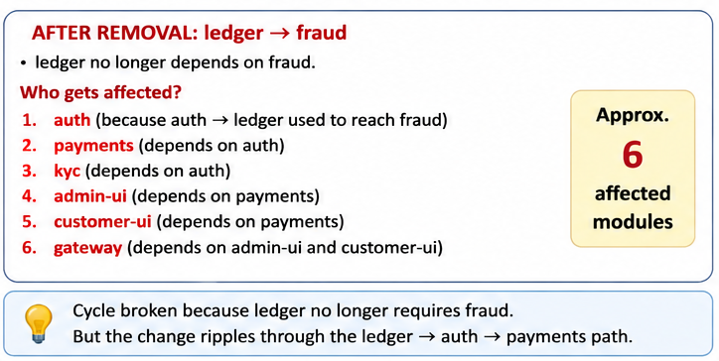

CASE 2 : Remove fraud → ledger
- Step 1: Remove fraud → ledger.
- Step 2: Cycle ledger → fraud → ledger is broken.
- Step 3: Fraud no longer depends on ledger.
- Step 4: Find affected modules.
- Step 5: Modules depending on fraud become stale.
- Step 6: Dependency path was payments → fraud → ledger.
- Step 7: Affected modules are payments, notify, admin-ui, customer-ui, and gateway.
- Step 8: Around 5 modules become affected.
- Step 9: Cycle is removed with smaller dependency impact.
